Terrain Classification from Reconnaissance Data

Final project proposal | W281 Spring 2024 Section 1

Maiya Caldwell, Muthumayan Madhayyan, Spencer Morris

***Dataset information***

* Link to dataset: [PatternNet](https://huggingface.co/datasets/jonathan-roberts1/PatternNet)
* Example images: please see sample images to the right
* Description of variation:
  + Original number of classes: 38
  + Resolution of images: 256x256 pixels
  + Image file formats: JPEG
  + Number of images per class: 800
  + Number of channels per image: 3 (RGB)
  + Total images in dataset: 30k

***Intended classification problem***

We intend to correctly classify (10 terrain classes) using the PatternNet terrain reconnaissance dataset. Solving this classification problem could be helpful in a variety of applications, such as emergency response during natural disasters, environmental monitoring and natural resource management, infrastructure development and urban planning, and more. We will focus on this subset of 10 classes from the original 38 available, covering a spectrum of natural vs. human-made, water vs. land-based terrain, to begin this journey.

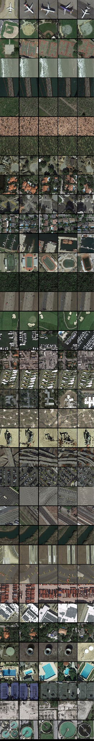

***Considered features***

We are considering using edges and color histograms to help our classification. Natural terrains appear to have a broader array of colors whereas human-made structures appear to have a more limited and consistent color palette. This can help us distinguish between some of our categories. Similarly, edge detection may be useful for identifying the more well-defined edges of manufactured terrains as well as the more complex edges of those more natural.